Mind Mapping Workshop

NC State University Libraries Activity Guide

# Introduction

* Open this document in a browser: <http://go.ncsu.edu/mindmap>
* Watch Mike Mind Map about himself

# Activity 1: Draw a Mind Map about Yourself

1. At the white board, quickly draw your face with your name underneath
2. Circle your face/name
3. Write ‘hobbies’ near your face and connect it with a curvy line
4. List a few hobbies and connect them with lines to the word ‘hobbies’
5. Repeat this branching structure for the topics of ‘people’ and ‘education’, using a different color marker for each branch
6. Draw another quick picture next to one of the end nodes
7. Tell us your name and about that node

# [Mike [presents about Mind Mapping](https://mm.tt/1322312200?t=H5HvmRqyyT)]

# Activity 2: Use MindMeister to Digitize Your Self Map

1. Go to mindmesiter.com in Chrome or other browser
2. Click ‘Sign Up with Google’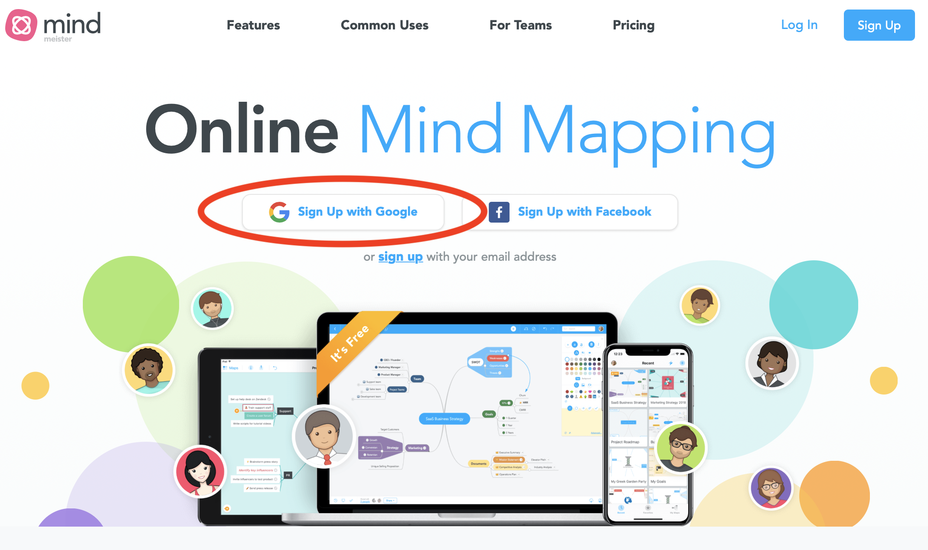
3. Enter your Unity credentials and perform 2FA
4. Agree to privacy policy and terms of service (skip promo emails)
5. Select ‘Education’ user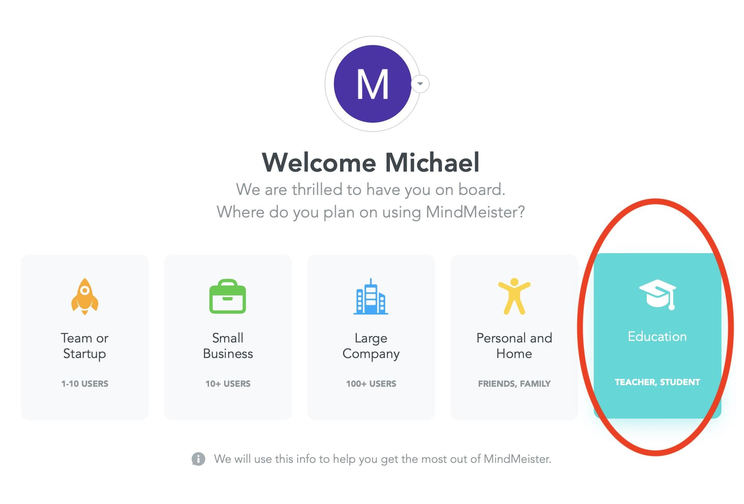
6. Click ‘Get Started’ on tutorial map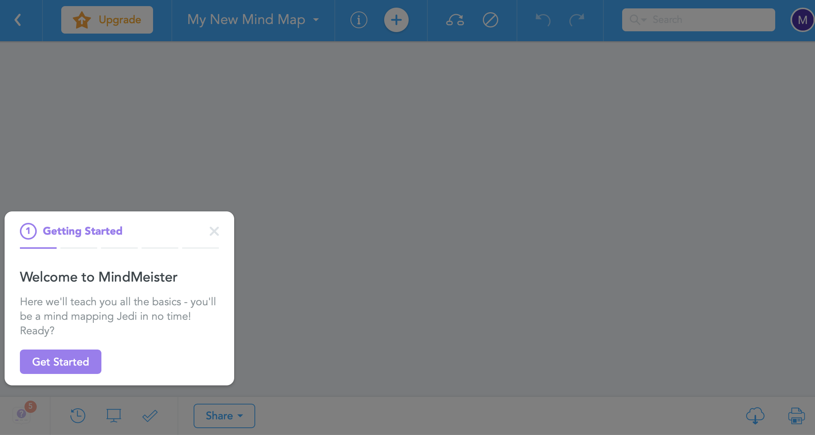
7. Add your name as the Title. Hit [enter].
8. Hit [tab] to add a main topic from your Self Map
9. Hit [enter] twice to add another main topic
10. Hit [enter] twice to add the last main topic
11. Drag and drop one of your topics onto another one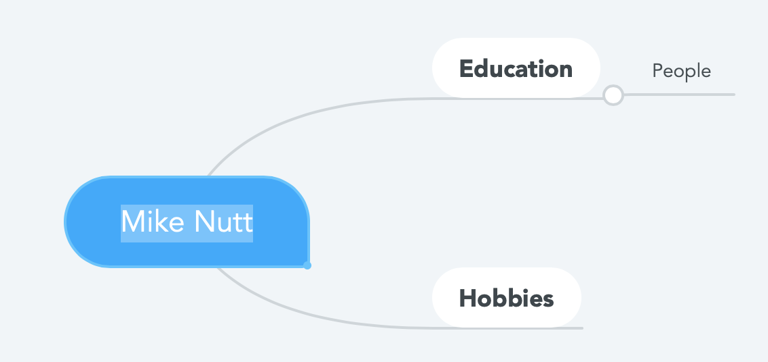
12. Undo: Move the topic back to connect to your name

# Activity 3: Practice Mind Mapping with MindMeister

1. Create a new mind map 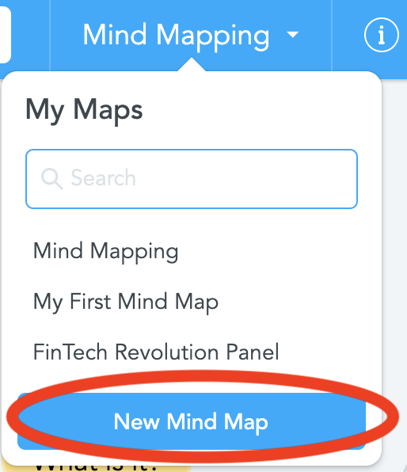
2. We will watch [Reos Partners: Student Services learnings from the Emergency Aid Lab](https://www.youtube.com/watch?v=U7gDxOB1sks)
3. Pre-map some main topics on your new mind map
   1. Put the speaker name at the center
   2. What is *your* research problem area?
   3. What do you already know?
   4. What do you think will be covered?
   5. What do you (or your instructor) want to find out?
   6. Are there topics listed in the abstract/description/conference program?
4. Mind map during the video, focusing on keywords and associations
5. Review your map.
6. Reorganize it (consolidate concepts, move branches, etc.)
7. Style it (e.g. add color, videos, links)
8. Share your mind map with the class
   1. How did it feel?
   2. Is there anything you’d do differently next time?
   3. Would it have been easier to draw? To just take notes?

# Activity 4: Exporting/Importing

1. In the bottom right corner, press the export button: 
2. Select ‘Document Outline’ and deselect ‘Include topic styling’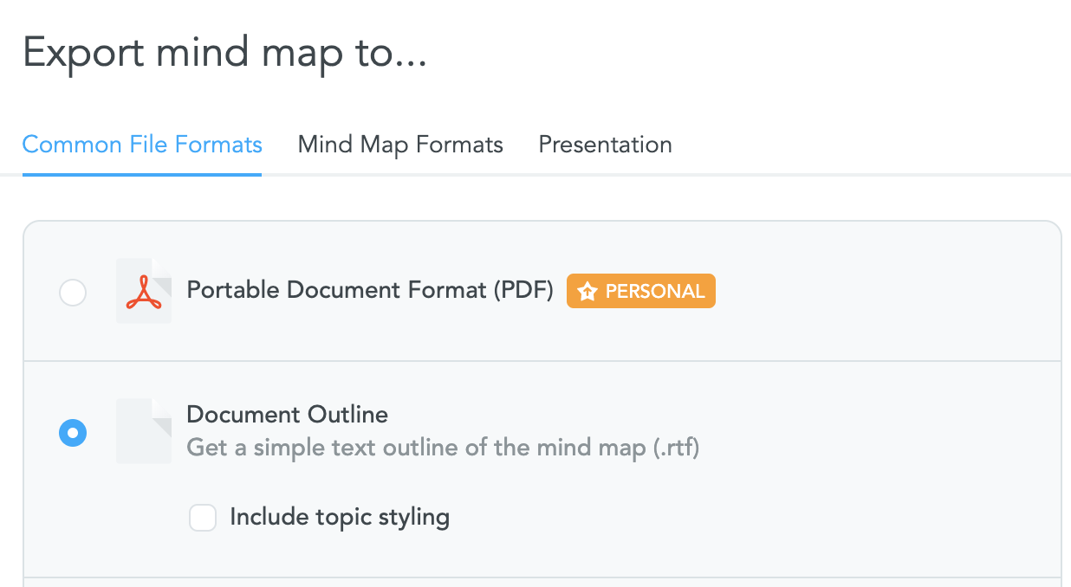
3. Click ‘Export...’ and save to ‘My Computer’
4. Select a location and click ‘Save’
5. Click on the .rtf file to open it in your operating system’s native text editor
6. To import a plain text or .mind file, click ‘Import’ from your MindMeister dashboard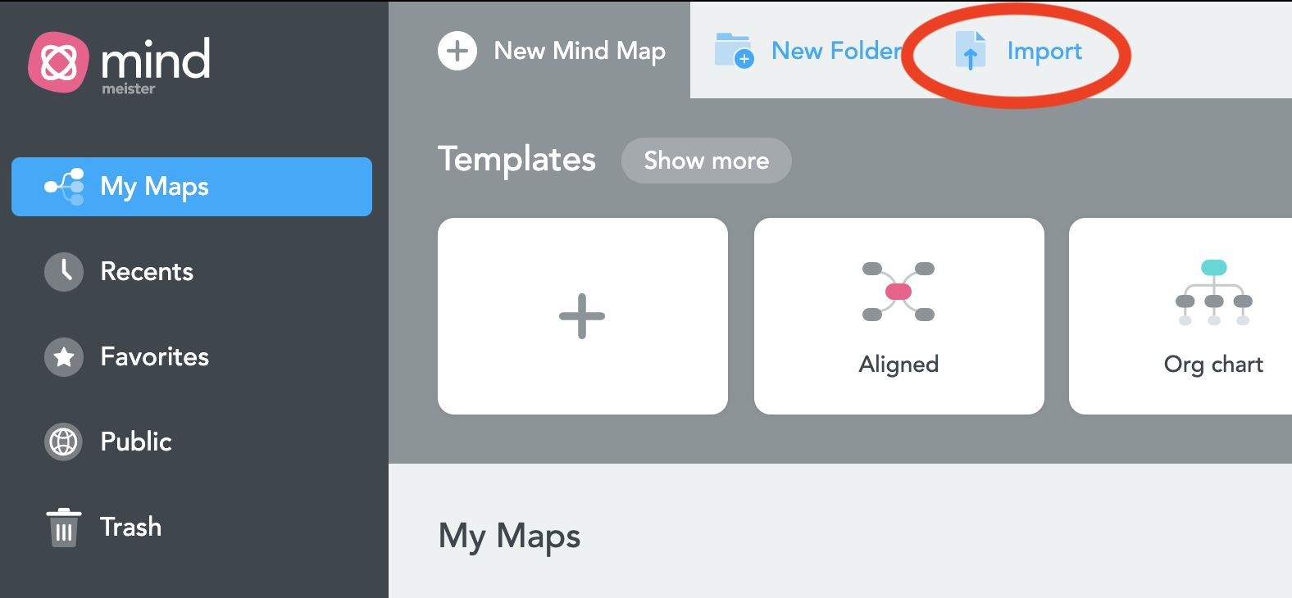

# Activity 5: Create a [presentation](https://support.mindmeister.com/hc/en-us/articles/203831618-How-to-Create-a-Mind-Map-Presentation) from your mind map

1. Think about what you’d like to present from your Emergency Aid map
2. Expand only the nodes you want to present
3. Click on the bottom to set up your presentation
4. Hold [cmd] and drag around the nodes you want in each slide
5. Click the button to play your presentation
6. Use arrow keys to navigate

# [Please fill out this evaluation](http://go.ncsu.edu/libeval)!